**EXPERIMENT NO- 4**

**RELATIONAL MODEL FOR SAILOR BOAT DATABASE**

**Aim**: Draw a relational for sailors database.

**OBJECTIVES:** The goal of the “Sailors-Boat” database is to enable members of a boat club to reserve boats for trips lasting several hours.

The two major entities are:

•**Sailors**—members of the boat club who reserve boats; and

•**Boats**—boats in the club's inventory. In this problem we need to know what boats are reserved by what sailors on a given day. Thus, "reservation" is obviously an important relationship in this simple problem.

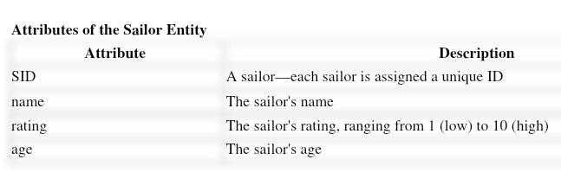

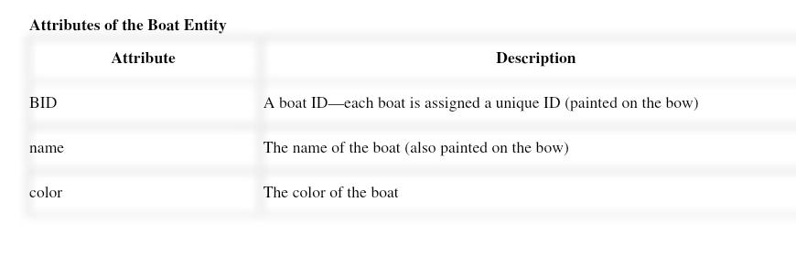

**We present a number of sample queries using the following schema:**

* + - Sailors(sid: integer, sname: string, rating: integer, age: real)
    - Boats(bid: integer, bname: string, color: string)
    - Reserves(sid: integer, bid: integer, day: date)

**->** We illustrate queries using the instances

S3 of Sailors, R2 of Reserves, and B1 of Boats, shown in Figure respectively**.**

**\*\*\*\* REALTIONAL MODEL ON SAILORS BOAT \*\*\*\***

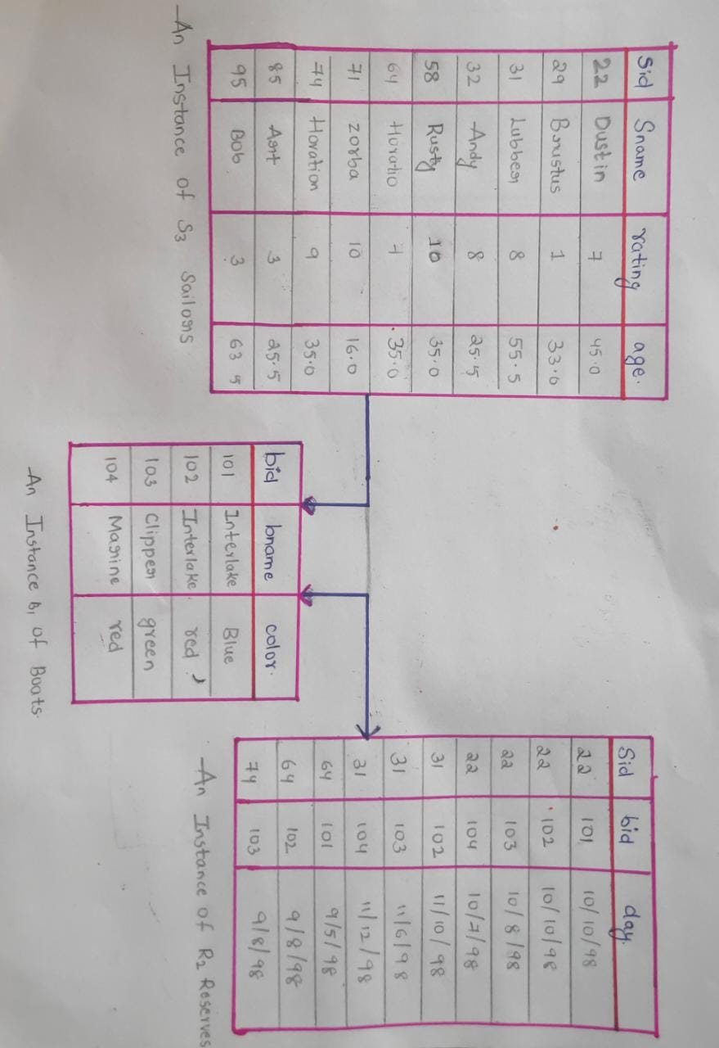

We now presenting several examples to illustrate how to write queries in relational algebra.

We use the Sailors, Reserves, and Boats schema for all our examples in this section.

We will use parentheses as needed to make our algebra expressions unambiguous. Note

that all the example queries are given a unique query number. The

query numbers are kept unique across both and the SQL query.

This numbering makes it easy to identify a query when it is revisited in

the context of relational calculus and SQL and to compare different ways of writing

the same query. (All references to a query can be found in the subject index).

